**AWT Components in Java**

28 Mar 2025 |  3 min read

**AWT** stands for **Abstract Window Toolkit**. It provides various GUI component classes like Label, Buttons, Text Boxes, Labels, and Menus, etc., to show window components on the screen. All these classes are part of the **Java.awt** package. It is heavy-weight.

[AWT](https://www.tpointtech.com/java-awt) is platform-dependent because it relies on the underlying [operating system (OS)](https://www.tpointtech.com/operating-system) and native [GUI](https://www.tpointtech.com/gui-full-form) components. It implies that an AWT-based program can be seen differently on [Linux](https://www.tpointtech.com/linux-tutorial), [macOS](https://www.tpointtech.com/what-is-macos) or [Windows](https://www.tpointtech.com/what-is-windows).

**AWT Hierarchy**

The following image represents the hierarchy for Java AWT.

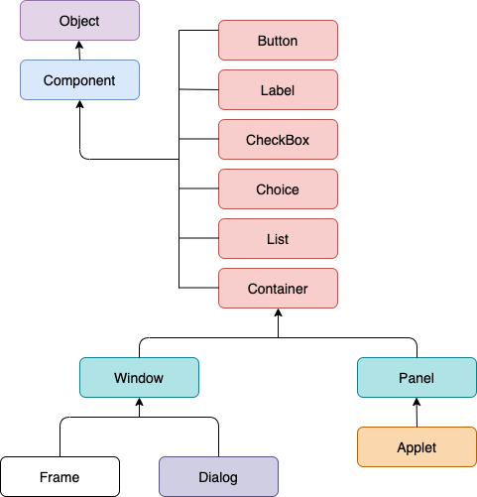

**AWT Components**

|  |  |  |
| --- | --- | --- |
| **S.N.** | **Component** | **Description** |
| **1** | **Button** | It is a simple push button that triggers an action when clicked. |
| **2** | **Canvas** | It is a blank rectangular area where custom graphics can be drawn. |
| **3** | **Checkbox** | It is a component that allows the user to select or deselect an option. |
| **4** | **Choice** | It is a drop-down list that allows the user to select a single item from a predefined set of options. |
| **5** | **Label** | It is a component that displays static text. |
| **6** | **List** | It is a component that displays a scrollable list of items, allowing the user to select one or more items. |
| **7** | **Scrollbar** | It is a component that allows the user to scroll through a large amount of content that exceeds the visible area. |
| **8** | **TextArea** | It is a multi-line text input area where the user can enter and edit text. |
| **9** | **TextField** | It is a single-line text input area where the user can enter and edit text. |
| **10** | **Frame** | It is a top-level window with a title bar and border, used as the main container for other AWT components. |
| **11** | **Panel** | It is a container that can hold other components, but does not have a title bar or border. |
| **12** | **Dialog** | It is a pop-up window used to display information or get input from the user. |
| **13** | **Menu** | It is a list of commands that can be accessed from a menu bar. |
| **14** | **MenuBar** | It is a bar at the top of a frame that contains menus. |
| **15** | **MenuItem** | It is an individual command within a menu. |

**AWT Java Program**

1. *//Java Program to create AWT application in Java*
2. **import** java.awt.*;
3. **public** **class** AwtApp **extends** Frame {
4. AwtApp(){
5. *//Creating AWT Components*
6. Label firstName = **new** Label("First Name");
7. firstName.setBounds(20, 50, 80, 20);
8. Label lastName = **new** Label("Last Name");
9. lastName.setBounds(20, 80, 80, 20);
10. Label dob = **new** Label("Date of Birth");
11. dob.setBounds(20, 110, 80, 20);
12. TextField firstNameTF = **new** TextField();
13. firstNameTF.setBounds(120, 50, 100, 20);
14. TextField lastNameTF = **new** TextField();
15. lastNameTF.setBounds(120, 80, 100, 20);
16. TextField dobTF = **new** TextField();
17. dobTF.setBounds(120, 110, 100, 20);
18. Button sbmt = **new** Button("Submit");
19. sbmt.setBounds(20, 160, 100, 30);
20. Button reset = **new** Button("Reset");
21. reset.setBounds(120,160,100,30);
22. *//Adding components on Frame*
23. add(firstName);
24. add(lastName);
25. add(dob);
26. add(firstNameTF);
27. add(lastNameTF);
28. add(dobTF);
29. add(sbmt);
30. add(reset);
31. *//Set size, layout and visibility of the frame*
32. setSize(300,300);
33. setLayout(**null**);
34. setVisible(**true**);
35. }
36. *//Creating main method to create the object of the class*
37. **public** **static** **void** main(String[] args) {
38. AwtApp awt = **new** AwtApp();
39. }
40. }

**Output:**

